Forestry & Carbon Sequestration by C. Kohn, Agricultural Sciences – Waterford WI
Name: Hour Date:
Date Assignment is due: end of the week Why late? Score: + ✓ -
^{Day of Week} ^{Date} If your project was late, describe why
Directions: This sheet will be due upon the completion of the week. This assignment is graded on a + /✓/ - scale. This lab is based on calculations and published material from the Trees for the Future organization and was created with help from Jeremy Solin, et. al of LEAF Forestry Education Program at the University of Wisconsin – Stevens Point. A calculator is needed for this lab.
- How many trees do you think it would take to offset the carbon dioxide produced by your lifestyle? Write your best estimate below:
I estimate I would need __________ trees to offset my lifestyle:
Why did you choose this number? Briefly explain how you came up with this amount:
- Based on what you know, what you’ve learned, and what you have heard, why should we care how much carbon dioxide is produced by our lifestyle? What impact does carbon dioxide have on the environment?
- Determine the height of your tree:
  - You can do this in a few different ways….(see attached methods)
    - Shadow Method
    - Student Method
    - Clinometer Method
Height of your Tree: feet
- What is the diameter of your tree? (Use a measuring tape to measure your circumference and divide by 3.14)
Circumference: ______________ in. ÷ 3.14 = ________________ in (diameter)
Diameter of your Tree:
- Next we need to determine the Green Weight of your tree - do a. or b., NOT both.
  - Does your tree have a diameter greater than 11 inches?
    - If so, use the following formula to find the green weight:
    - Green weight = 0.15D²H(1.2)
(0.15)(___________ inches)² x (__________ feet) x (1.2) = __________________________lbs Green weight
^{diameter} ^{height}
-or-
  - Does your tree have a diameter less than 11 inches?
    - If so, use the following formula:
    - Green weight = 0.25D²H(1.2)
(0.25)(___________ inches)² x (__________ feet) x (1.2) = ________________________lbs Green weight
^{diameter} ^{height}
Green Weight of your Tree: lbs
- Next we need to use the green weight of the tree to determine the dry weight of the tree.
  - To find the dry weight of the tree, multiply your Green Weight by 72.5% (or 0.725)
Green Weight: __________________ x 0.725 = _______________________lbs (Dry Weight)
Dry Weight of your Tree: lbs
- Next we need to determine the weight of the carbon atoms in the dry weight of the tree. Because trees are roughly 50% carbon (when dry), we simply have to multiply our dry weight by 0.5 to find the weight of carbon in the tree.
  - Simply multiply your dry weight by ½ to find the weight of carbon sequestered in your tree.
Dry weight: ___________________________ x 0.5 = _____________________ (weight of carbon)
Carbon sequestered by your Tree: lbs

- Next we need to determine how much CO2 can be absorbed by a tree based on its carbon content. Because carbon is a little over a third of the weight of CO2, we simply multiply our carbon weight by 3.67 to determine the weight of CO2 absorbed.
Weight of carbon: _______________ x 3.67 = ___________________________lbs CO2 sequestered
Carbon Dioxide sequestered by your Tree: lbs

- Using a carbon footprint calculator, how many pounds of CO2 do you emit per year?
Pounds of Carbon Dioxide emitted by your lifestyle: lbs
(If you do not know, visit http://www.nature.org/greenliving/carboncalculator/index.htm to determine your footprint)
- Divide the pounds of carbon dioxide that you emit by the CO2 sequestered by your tree to determine the number of trees you would have to plant to neutralize your carbon footprint:
__________ lbs CO₂ emitted by lifestyle ÷ __________ lbs CO₂ sequestered by this tree = __________ trees needed
9. How many trees would you have to plant to offset the carbon dioxide emitted because of your lifestyle?
I would need to plant trees to offset the carbon dioxide produced by my lifestyle.
- How does the number of trees needed (according to you calculations) compare to the number of trees you estimated you would need at the beginning of this lab? Was this surprising to you?
- Is it better to have carbon in an organic form (as part of a tree) or in an inorganic form (as CO2)? Explain:
- Why would it be a good idea to plant enough trees to offset your carbon dioxide production? -AND- How could this help the environment? Explain in detail.
- Are you more likely or less likely to change your lifestyle as a result of this lab? Explain:
More / Less ^{(circle one)} Explain:
- If every American planted the number of trees needed to offset the carbon dioxide emissions created as a result of their lifestyle, how would natural environments change? Would this be environmentally beneficial? Explain:
- If every American planted the number of trees needed to offset the carbon dioxide emissions of their lifestyle, would we still need to do other things to protect the planet, or would this action by itself be enough? Explain:
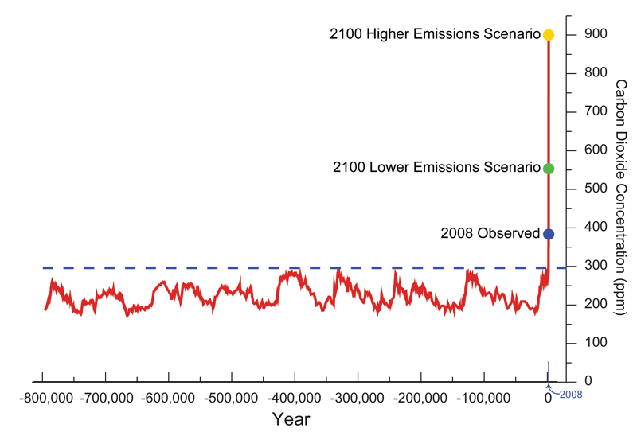
- This graph shows CO2 levels in the atmosphere over a period of hundreds of thousands of years:
Based on this graph, do you think the Americans should be required to plant the number of trees needed to offset the equivalent of their carbon dioxide emissions? Answer yes or no and explain your reasoning:

Measuring the height of a tree:

Shadow method (if there are visible shadows and you have access to calculators):
- Have students measure the height in inches of a group member
- Next, have students measure their shadow in inches.
- Third, measure the shadow of the tree in question in inches.
- Complete this equation:
[student height: ______in] ÷ [shadow length: ______in] x [tree shadow ______in] = tree height: ________in
Tree height _______________ in ÷ 12 = _______________(tree height in feet)

Student Method:
- Have students measure their own height (in cm).
- Student A stands under a tree while student B stands a distance away. (about 20 paces)
- Student B holds a pencil at arm’s length and covers part of the pencil so that the visible part is the same length as Students A's height.
- Student B now moves the pencil up the tree and measures how many times taller the tree is than Student A.
- Simply multiply this number times Student A's height and you have a good estimate of the tree's height. Example: Student A is 150 cm tall. Student B found that the tree is about four times taller than student A. So 150 cm x 4 = 600 cm. The tree is approximately 6 meters tall.
  - Source: http://www.na.fs.fed.us/spfo/pubs/uf/lab_exercises/how_big_is_a_tree.htm

Clinometer Method
Materials
100 foot tape
Clinometer
Procedure
Choose a wooded area in which some large tree crowns are meshed into one another, and where there is a fairly distinct slope. Explain that a clinometer works on triangulation based on one of the sides of the triangle being 100 feet. Have a student hold the end of the 100 foot tape at the mid-section of a tree to be measured. Have another student run the tape out to 100 feet and mark the end of the tape. Make sure the second student did not go down slope or up slope from the tree. Make sure that the tree apex is discernible from the 100 foot mark. Have the student look through the clinometer eyepiece toward the tree apex. The student must keep both eyes open. One eye tracks the tree top while the other eye lines up the cross hair within the clinometer with the tree top. The student reads the measurements on the right-hand side of the clinometer. This is the tree height in feet. Groups of three to four students are recommended, so that measurements can be compared for accuracy.
Source: http://www.na.fs.fed.us/spfo/pubs/uf/lab_exercises/measuring_tree_heights.htm

