AP Lab 12 Pre-Lab
Dissolved Oxygen and Aquatic Primary Productivity
http://www.phschool.com/science/biology_place/labbench/lab12/intro.html

- Explain the effects of the following factors on oxygen availability:

  - Salinity –
  - Temperature –
  - Decomposition –
  - Mixing/turbulence –
  - Photosynthetic activity –

- _______________________________________ describes the rate at which photosynthetic organisms produce organic compounds in an ecosystem.

  - ___________________________________ = entire photosynthetic production of organic compounds in an ecosystem

  - ___________________________________= remaining organic materials after photosynthetic organisms have used compounds for cellular respiration.

- The equation for photosynthesis is:

- List the 3 ways primary productivity can be measured, and circle the method we will use in this lab:

  - .

  - .

  - .

- What is the percent oxygen saturation for a water sample at 10° C that has 7 mg O₂/L?

- What is the percent oxygen saturation for a water sample at 25° C that has 7 mg O₂/L?

Sample Problem
A biology student inadvertently removed all the screens and labels from the water-sampling bottles before he measured the amount of dissolved oxygen. When he tested the unidentified bottles, he obtained the results shown below.
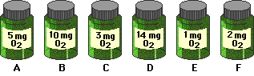
The initial oxygen reading for this water was 4 mg O₂/l. Based on the results predicted by the hypothesis that light increases productivity, enter the letter of the bottle that corresponds to each light percentage. Then complete the rest of the table and, using the graph below as a model, graph the gross and net productivity for these data. Print the completed data table and attach to this pre-lab.
If you are having trouble with these calculations, take a side trip to learn about gross productivity, net productivity or to get additional help.
% Light | Bottle | Gross Productivity  (light bottle – dark bottle) | Net Productivity  (light bottle – initial bottle)
0

2

10

25

35

100

Graphing Hints
1. | Be sure to label both x- and y-axes on the graph. Place the independent variable on the x-axis and the dependent variable on the y-axis.
2. | Be sure to mark units correctly on the graph — the interval between 2% light and 10% light is NOT the same as the interval between 10% and 25%!

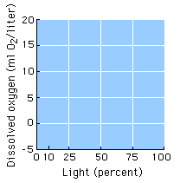

Lab Quiz
List answers to the Lab Quiz below:
- ____________ 2. ____________ 3. ____________ 4. ____________

Please answer the following questions:

- Explain the differences between the ability of aquatic vs. terrestrial environments to hold oxygen.

- Contrast eutrophic and oligotrophic bodies of water:

- The most productive system in terms of primary production in the world is:

